
RETORIKA: Jurnal Ilmu Bahasa
Vol. 11, No. 1 April 2025, Page 96-103

P-ISSN: 2406-9019
E-ISSN: 2443-0668
Available Online at https://ejournal.warmadewa.ac.id/index.php/jret

Analysis of Harf Halq Intonation Patterns in Imperative Sentence Pronunciation Based on PRAAT Application-Based Frequency Values

Sri Yulia Yuliani¹, Asep Sopian², Hikmah Maulani³

^{1,2,3} Universitas Pendidikan Indonesia
Email: sriyuliayuliani24@upi.edu, asepsopian@upi.edu, hikmahmaulani@upi.edu
How to cite (in APA style):
Yuliani, S. Y., Sopian, A., & Maulani, H. (2025). Analysis of Harf Halq Intonation Patterns in Imperative Sentence Pronunciation Based on PRAAT Application-Based Frequency Values. Retorika: Jurnal Ilmu Bahasa, 11(1), 96-103. Doi: http://10.55637/jr.11.1.10998.96-103
Published: 30/04/2025

Abstract- The intonation or variation of tone produced by a speaker when pronouncing a sentence or its parts greatly influences the meaning of the sentence, especially for halq letters that have similar pronunciations to each other. This is evident in sounds such as hamzah and 'ain, as well as kha and ha, in the imperative sentences studied in this research. Intonation not only functions as a marker of literal meaning, but also as a tool to convey emotional nuance, intensity and politeness. In the context of imperative sentences, intonation can distinguish between a firm command, a polite request, or even an urgent plea. This study aims to validate the intonation pattern theory proposed by Al-'Aini and Verhaar, which states that the common intonation patterns in Arabic imperative sentences are /2-3-1/ and /3-2-1/. This study uses a qualitative comparative method with a focus on frequency analysis through intonation patterns in verbal data. PRAAT software was used for spectral analysis and voice frequency measurement. The findings showed that out of six participants, four participants showed intonation patterns consistent with Al-'Aini and Verhaar's theories, which were validated through their alignment with native Arabic speakers' speech patterns. Meanwhile, the other two participants showed a variety of inappropriate intonation patterns. Factors such as the influence of the participants' mother tongue, incorrect emphasis or nabr, and lack of awareness regarding proper intonation patterns contributed to this difference. The findings are expected to enhance the theory of intonation in Arabic linguistics and help validate the theory of intonation patterns in Arabic imperative sentences proposed by Al-'Aini and Verhaar by examining the alignment of these patterns with the intonation of participants (non-native speakers) and native Arabic speakers.

Keywords: Arabic Phonology, Intonation Analysis, Speech Frequency Patterns.

INTRODUCTION
Intonation is one of the critical aspects of phonology that influences the meaning of an utterance. Intonation refers to the variation in pitch to convey a specific intended meaning. This meaning may include questions, statements, commands, requests, anger, joy, surprise, admiration, enthusiasm, and more (داود، 2001). According to Kridalaksana, intonation is the pattern of pitch variations produced by a speaker when pronouncing a sentence or its parts. The pitch characteristics of a language are unique to each language (أنيس، 1954). Ahmad Mukhtar Umar explains it more simply, defining intonation as the level of sound within a sentence or phrase. Intonation serves as a means of expression, ensuring that the intended meaning of the spoken words is well-received by the listener (Arman, 2015).
Intonation follows specific patterns for each word or sentence. For instance, high and low patterns indicate different meanings in a word or sentence. This helps distinguish sentence types, whether offensive, informative, provocative, or sarcastic (Utomo, 2022). Al-’Aini and Verhaar classify pitch variation into four levels:
- Low pitch, marked as 1.
- Medium pitch, marked as 2.
- High pitch, marked as 3.
- Very high pitch, marked as 4 (Thoyib, 2019).
In Arabic, intonation not only aids in understanding sentence meaning but also plays a role in conveying the speaker’s emotional nuances and attitudes (Qomariyah, 2017). Imperative sentences or commands are a type of sentence where intonation greatly determines whether the command is firm, gentle, urgent, or merely suggestive. According to The Phonology of Arabic by Dr. Thoyib, Al-'Ani identifies specific pitch patterns in Arabic imperative sentences, typically following the /2-3-1/ pattern. The placement of the level /3/ depends on which word the speaker emphasizes. Thus, level /3/ may occur initially, creating a /3-2-1/ pattern. For example:
/ ارْفَعْ يَدَكَ / 2-3-1
/irfa’ yadaka/ ‘Raise your hand.’
In Arabic, a sentence may convey different meanings depending on the intonation used. A sentence can signify lamentation (tahassur), reproach (zajr), dissatisfaction (‘adam ar-rida’), surprise (dahshah), and more (Romanda, 2021). The meaning embedded in a sentence can be identified from the intonation used. Therefore, intonation plays a crucial role in determining meaning in Arabic (Hijazi, 1997). For instance, the phrase يا شيخ (yaa shaykh) in Arabic can be uttered with various intonations. Its intonation can imply a call with a /2-3-1/ pattern or a question with a /3-2-1/ pattern. Linguistically, intonation patterns illustrate sentence diversity. For example, the intonation pattern for a calling sentence cannot be used for an interrogative sentence (Rois, 2022).
The study of intonation in the pronunciation of imperative sentences in Arabic is very relevant, especially in the context of Arabic education as a second language. A good understanding of intonation patterns can help Arabic learners to master more natural and precise pronunciation, thus being able to communicate more effectively (أنيس، 1954; Annisa, 2023). This study focuses on analyzing the intonation pattern of harf halq which is similar in pronunciation, namely hamzah with 'ain and kha with ha in the pronunciation of imperative sentences [Ɂismaʕ - ma:juri:du xali:lu - Ɂan jaqu:la]. The analysis was conducted based on frequency values using PRAAT, a sophisticated phonetic analysis tool widely used in linguistic studies (Boersma & Weenink, 2020). The PRAAT app allows for detailed and accurate analysis of various aspects of phonetics, including voice frequency which is closely related to intonation.
This study aims to validate the intonation pattern theory for Arabic imperative sentences proposed by Al-‘Aini and Verhaar by examining the alignment of these patterns with the intonation of participants (non-native speakers) and native Arabic speakers. The findings of this research can serve as a foundation for further studies focusing on intonation and other phonetic aspects in Arabic.

METHODS
This study uses a qualitative comparative method with a focus on frequency analysis through intonation patterns. Qualitative research is used to present data as it is in its natural setting (Nadirah, 2022). In the context of this research, data or information is derived from the students’ reading test results using the Qira’ah Rasyidah textbook. The research design involves content analysis of verbal data obtained from sentences read aloud by students when reading Arabic texts.
The participants in this study are six eighth-grade students and two native speakers as comparators. The sampling method used in this study is non-probability sampling with a purposive sampling technique. The sample criteria for this study include eighth-grade students who have passed the BTAQ reading competency, are proficient in reading fluently, and can read fluently with comprehension.
The data collection techniques employed include documentation studies using listening, noting, and recording techniques, as well as reading tests conducted on the students. The process of data collection and data analysis in this research utilizes the PRAAT application. Figure 1 below illustrates a block diagram outlining the speech data sample analysis process leading to the research outcomes.

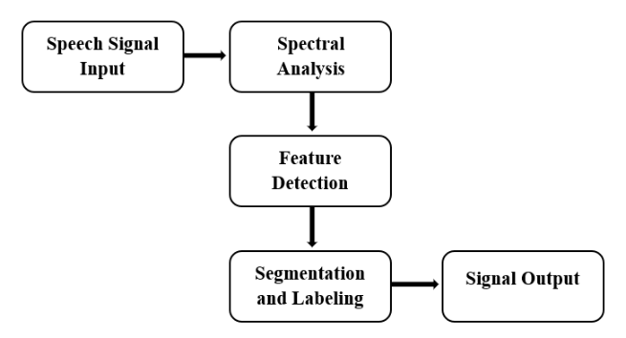

Figure 1. Speech Data Analysis Process
(Source: Ningsih, 2020)
The figure above explains the steps in the analysis: (1) inputting speech signal data sourced from recordings, (2) spectral analysis (sound waves and spectrogram), (3) detecting suprasegmental features as needed, (4) segmentation and labeling of speech signals and their output in Hz (Ningsih, 2020). In this study, the features measured are intonation patterns in imperative sentences based on frequency values (pitch).
Once frequency data is obtained, an analysis of intonation patterns is conducted based on the theories of Al-‘Aini and Verhaar. The analysis is validated by comparing the alignment of intonation patterns between participants (non-native speakers) and the utterances of native speakers, which are represented through pitch contours.

RESULT AND DISCUSSION
The results of this study are depicted in Table 1. about the analysis of intonation patterns of imperative sentences based on frequency values. Through the analysis of pitch values, the results of students' pronunciation intonation patterns in imperative sentences are different. Based on Al-’Aini and Verhaar's theory in the book “Arabic Phonology Modern Arabic Language Structure”, it is explained that intonation in imperative sentences generally has the pattern /2-3-1/ and /3-2-1/ (Thoyib, 2019).
Table 1. Analysis of Imperative Sentence Intonation Pattern Based on Frequency Value
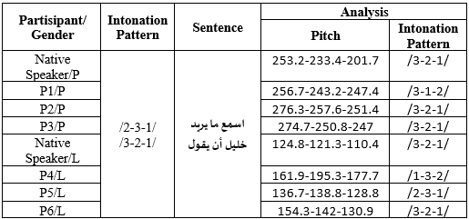
Based on the table above, the intonation patterns of male and female native speakers have the same intonation pattern, namely /3-2-1/. This is in accordance with the theory of intonation patterns of Arabic sentence tones proposed by Al-’Aini and Verhaar in a book entitled “Arabic Phonology Modern Arabic Language Structure”. Then P2/p, P3/p, and P6/l have intonation patterns that are in accordance with the original speech and the theory of intonation patterns of Arabic sentence tones. P5/l produces the appropriate intonation pattern which is /2-3-1/. Meanwhile, P1/p and P4/l have inappropriate intonation patterns, namely /3-1-2/ and /1-3-2/. The tone at the end of the sentence which should be lowered is pronounced higher than the previous tone. To get a clearer picture, the researcher will discuss the tone contour of each participant.
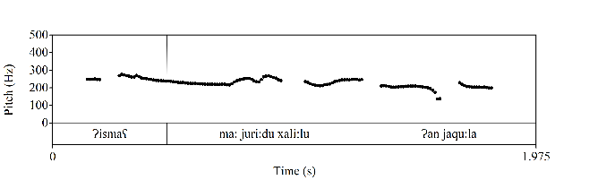
Figure 2. Tone Contour of Female Native Speaker
Figure 2 above shows the pitch contour of the native female speaker's pronunciation of the imperative sentence [Ɂismaʕ - ma: juri:du xali:lu - Ɂan jaqu:la] with a frequency value of 253.2 Hz-233.4 Hz-201.7 Hz. The word [Ɂismaʕ] with a frequency of 253.2 Hz is a high tone marked with the number 3, [ma: juri:du xali:lu] is a medium tone with a frequency of 233.4 Hz marked with the number 2, and [Ɂan jaqu:la] is a low or falling tone with a frequency of 201.7 Hz marked with the number 1. So that it produces an intonation pattern /3-2-1/ which is in accordance with the theory of Arabic tonal intonation patterns proposed by Al-’Aini and Verhaar in Dr. Thoyib's book that the tone in Arabic in command/imperative sentences is usually patterned /2-3-1/ or /3-2-1/ according to the stress (nabr) of the word being pronounced (Thoyib, 2019). Then the frequency value of female native speakers above is in accordance with the theory of Ball and Muller, (2005: 8) which explains that the average fundamental frequency in speech for women is 265 Hz (Irawan, Y. & Dinakaramani, A., 2019). While the frequency range is between 180-400 Hz (Kridalaksana, 1982; Jamil, 2017).

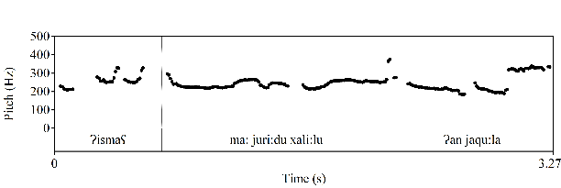
Figure 3. Tone Contour of Female Participant 1
Figure 3 above shows the pitch contour of female participant 1's pronunciation of the imperative sentence [Ɂismaʕ - ma: juri:du xali:lu - Ɂan jaqu:la] with frequency values of 256.7 Hz-243.2 H z - 2 4 7 .4 Hz. The word [Ɂismaʕ] with a frequency of 256.7 Hz is a high tone marked with number 3, [ma: juri:du xali:lu] with a frequency of 243.2 Hz has a decrease in tone (low tone) marked with number 1, and [Ɂan jaqu:la] with a frequency of 247.4 Hz has an increase in tone (medium tone) marked with number 2. So that it produces an intonation pattern /3-1-2/ which is not in accordance with the theory of Arabic tonal intonation patterns proposed by Al-’Aini and Verhaar in Dr. Thoyib's book that the tone in Arabic in command/imperative sentences is usually patterned /2-3-1/ or /3-2- 1/ according to the stress (nabr) of the word being pronounced (Thoyib, 2019).
This occurs due to several factors, including the influence of the mother tongue, inappropriate word stress/abrasion, ignorance of intonation patterns, and others. This is in line with research on the phonological interference process, one of the factors causing it is the influence of the mother tongue (Kholis, 2019; Mamnunah, 2021; Wati, 2023). And the theory explains that the sound of emphasis in a word can determine the meaning, so the stress/abrasion in a word must be appropriate (Romanda, 2021). However, the frequency value of the female participants above is in accordance with the theory of Ball and Muller, (2005: 8) which explains that the average fundamental frequency in speech for women is 265 Hz (Irawan, Y. & Dinakaramani, A., 2019). While the frequency range is between 180-400 Hz (Kridalaksana, 1982; Jamil, 2017).
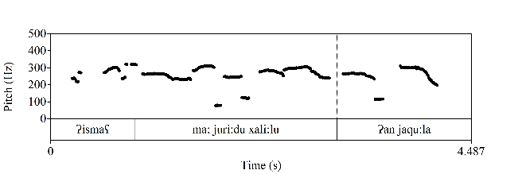
Figure 4. Tone Contour of Female Participant 2
Figure 4 above shows the pitch contour of female participant 2's pronunciation of the imperative sentence [Ɂismaʕ - ma: juri:du xali:lu - Ɂan jaqu:la] with frequency values of 276.3 Hz-257.6 Hz-251.4 H z . The word [Ɂismaʕ] with a frequency of 276.3 Hz is a high tone marked with the number 3, [ma: juri:du xali:lu] is a medium tone with a frequency of 257.6 Hz marked with the number 2, and [Ɂan jaqu:la] is a low or falling tone with a frequency of 251.4 Hz marked with the number 1. So that it produces an intonation pattern /3-2-1/ which is in accordance with the theory of Arabic tonal intonation patterns proposed by Al-’Aini and Verhaar in Dr. Thoyib's book that the tone in Arabic in command/imperative sentences is usually patterned /2-3-1/ or /3-2-1/ according to the stress (nabr) of the word being pronounced (Thoyib, 2019). Then the frequency value of female participants above is in accordance with the theory of Ball and Muller, (2005: 8) which explains that the average fundamental frequency in speech for women is 265 Hz (Irawan, Y. & Dinakaramani, A., 2019). While the frequency range is between 180-400 Hz (Kridalaksana, 1982; Jamil, 2017).
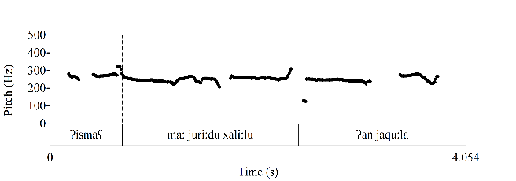
Figure 5. Tone Contour of Female Participant 3
Figure 5 above shows the pitch contour of female participant 3's pronunciation of the imperative sentence [Ɂismaʕ - ma:juri:du xali:lu - Ɂan jaqu:la] with frequency values of 274.7 Hz-250.8 Hz-247 Hz. The word [Ɂismaʕ] with a frequency of 274.7 Hz is a high tone marked with number 3, [ma:juri:du xali:lu] is a medium tone with a frequency of 250.8 Hz marked with number 2, and [Ɂan jaqu:la] is a low or descending tone with a frequency of 247 Hz marked with number 1. So that it produces an intonation pattern /3-2-1/ which is in accordance with the theory of Arabic tonal intonation patterns proposed by Al-’Aini and Verhaar in Dr. Thoyib's book that the tone in Arabic in command/imperative sentences is usually patterned /2-3-1/ or /3-2-1/ according to the stress (nabr) of the word being pronounced (Thoyib, 2019). Then the frequency value of female participants above is in accordance with the theory of Ball and Muller, (2005: 8) which explains that the average fundamental frequency in speech for women is 265 Hz (Irawan, Y. & Dinakaramani, A., 2019). While the frequency range is between 180-400 Hz (Kridalaksana, 1982; Jamil, 2017).
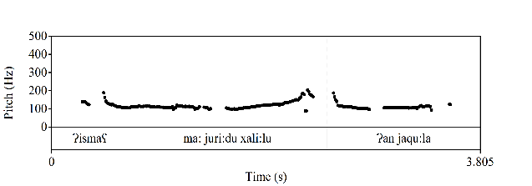
Figure 6. Tone Contour of Male Native Speaker
Figure 6 above shows the pitch contour of the native male speaker's pronunciation of the imperative sentence [Ɂismaʕ - ma: juri:du xali:lu - Ɂan jaqu:la] with frequency values of 124.8 Hz-121.3 Hz-110.4 Hz. The word [Ɂismaʕ] with a frequency of 124.8 Hz is a high tone marked with the number 3, [ma: juri:du xali:lu] is a medium tone with a frequency of 121.3 Hz marked with the number 2, and [Ɂan jaqu:la] is a low or falling tone with a frequency of 110.4 Hz marked with the number 1. So that it produces an intonation pattern /3-2-1/ which is in accordance with the theory of Arabic tonal intonation patterns proposed by Al-’Aini and Verhaar in Dr. Thoyib's book that the tone in Arabic in command/imperative sentences is usually patterned /2-3-1/ or /3-2-1/ according to the stress (nabr) of the word being pronounced (Thoyib, 2019). Then the frequency value of the male native speaker above is in accordance with the theory of Ball and Muller, (2005: 8) which explains that the average fundamental frequency in speech for men is 120 Hz (Irawan, Y. & Dinakaramani, A., 2019). While the frequency range is between 60-240 Hz (Kridalaksana, 1982; Jamil, 2017).
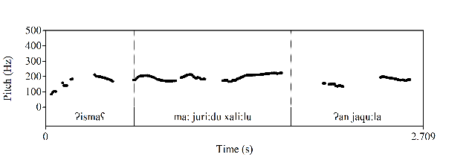

Figure 7. Tone Contour of Male Participant 4
Figure 7 above shows the pitch contour of male participant 4's pronunciation of the imperative sentence [Ɂismaʕ - ma: juri:du xali:lu - Ɂan jaqu:la] with a frequency value of 161.9 Hz-195.3 Hz-177.7 Hz. The word [Ɂismaʕ] with a frequency of 161.9 Hz is a low tone marked with number 1, [ma: juri:du xali:lu] with a frequency of 195.3 Hz has an increase in tone (high tone) marked with number 3, and [Ɂan jaqu:la] with a frequency of 177.7 Hz has a decrease in tone from before (medium tone) marked with number 2. So that it produces an intonation pattern /1-3-2/ which is not in accordance with the theory of Arabic tonal intonation patterns proposed by Al-’Aini and Verhaar in Dr. Thoyib's book that the tone in Arabic in command/imperative sentences is usually patterned /2-3-1/ or /3-2-1/ according to the stress (nabr) of the word being pronounced (Thoyib, 2019).
This occurs due to several factors, including the influence of the mother tongue, inappropriate word stress/abrasion, ignorance of intonation patterns, and others. This is in line with research on the phonological interference process, one of the factors causing it is the influence of the mother tongue (Kholis, 2019; Mamnunah, 2021; Wati, 2023). And the theory explains that the sound of emphasis in a word can determine the meaning, so the stress/abrasion in a word must be appropriate (Romanda, 2021). However, the frequency value of the male participants above is in accordance with the theory of Ball and Muller, (2005: 8) which explains that the average fundamental frequency in speech for men is 120 Hz (Irawan, Y. & Dinakaramani, A., 2019). While the frequency range is between 60-240 Hz (Kridalaksana, 1982; Jamil, 2017).
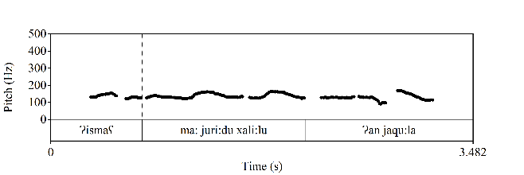
Figure 8. Tone Contour of Male Participant 5
Figure 8 above shows the pitch contour of male participant 5's pronunciation of the imperative sentence [Ɂismaʕ - ma: juri:du xali:lu - Ɂan jaqu:la] with frequency values of 136.7 Hz-138.8 Hz-128.8 Hz. The word [Ɂismaʕ] with a frequency of 136.7 Hz is a medium tone marked with the number 2, [ma: juri:du xali:lu] has an increase in tone (high tone) with a frequency of 138.8 Hz marked with the number 3, and [Ɂan jaqu:la] is a low or falling tone with a frequency of 128.8 Hz marked with the number 1. So that it produces an intonation pattern /2-3-1/ which is in accordance with the theory of Arabic tonal intonation patterns proposed by Al-’Aini and Verhaar in Dr. Thoyib's book that the tone in Arabic in command/imperative sentences is usually patterned /2-3-1/ or /3-2-1/ according to the stress (nabr) of the word being pronounced (Thoyib, 2019). Then the frequency value of the male participants above is in accordance with the theory of Ball and Muller, (2005: 8) which explains that the average fundamental frequency in speech for men is 120 Hz (Irawan, Y. & Dinakaramani, A., 2019). While the frequency range is between 60-240 Hz (Kridalaksana, 1982; Jamil, 2017).
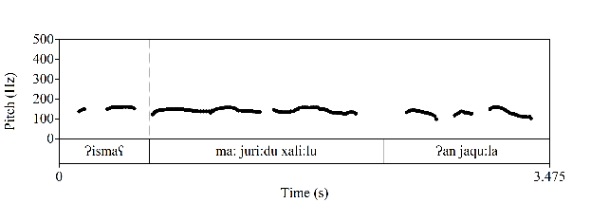
Figure 9: Tone Contour of Male Participant 6
Figure 9 above shows the tone contour of male participant 6's pronunciation of the imperative sentence [Ɂismaʕ - ma: juri:du xali:lu - Ɂan jaqu:la] with a frequency value of 154.3 Hz-142 Hz-130.9 Hz. The word [Ɂismaʕ] with a frequency of 154.3 Hz is a high tone marked with the number 3, [ma: juri:du xali:lu] is a medium tone with a frequency of 142 Hz marked with the number 2, and [Ɂan jaqu:la] is a low or falling tone with a frequency of 130.9 Hz marked with the number 1. So that it produces an intonation pattern /3-2-1/ which is in accordance with the theory of Arabic tonal intonation patterns proposed by Al-’Aini and Verhaar in Dr. Thoyib's book that the tone in Arabic in command/imperative sentences is usually patterned /2-3-1/ or /3-2-1/ according to the stress (nabr) of the word being pronounced (Thoyib, 2019). Then the frequency value of the male participants above is in accordance with the theory of Ball and Muller, (2005: 8) which explains that the average fundamental frequency in speech for men is 120 Hz (Irawan, Y. & Dinakaramani, A., 2019). While the frequency range is between 60-240 Hz (Kridalaksana, 1982; Jamil, 2017).
Therefore, based on the explanation above, it can be concluded that nearly all participants and native speaker utterances exhibit intonation patterns in the pronunciation of harf halq in imperative sentences that align with the patterns /2-3-1/ and /3-2-1/. However, two participants, namely Participant 1 (female) and Participant 4 (male), displayed less accurate intonation patterns, which followed /3-1-2/ and /1-3-2/. This discrepancy arises due to several factors, including the influence of the mother tongue, improper stress (nabr) on certain words, lack of knowledge regarding intonation patterns, and other aspects consistent with studies on phonological interference processes. One significant factor causing such interference is the influence of the mother tongue (Kholis, 2019; Mamnunah, 2021; Wati, 2023). Additionally, theories suggest that stress on specific words can determine meaning; therefore, stress (nabr) on words must be applied correctly (Romanda, 2021) along with other suprasegmental aspects.
These findings have theoretical implications for validating the theories of Al-‘Aini and Verhaar, enriching the literature on phonology and intonation in the Arabic language, and paving the way for further theoretical development of intonation in Arabic and other languages. Practically, understanding these intonation patterns can be applied to Arabic language teaching, assisting educators in designing more effective teaching strategies and enhancing students' speaking and reading skills. This study also provides concrete empirical data on intonation patterns in Arabic imperative sentences, which can serve as a reference for future research. Furthermore, this data is valuable for comparative studies with other languages and for advancing speech recognition technology focusing on Arabic intonation.

CONCLUSION
The research findings indicate that the intonation patterns of harf halq in imperative sentences follow the patterns /3-2-1/ and /2-3-1/, consistent with the theory of Al-‘Aini and Verhaar, as validated by their alignment with the intonation patterns of native Arabic speakers. Among the six participants, four demonstrated accurate patterns, while the other two exhibited variations in intonation patterns that did not align with the expected norms.
Deviations in the observed intonation patterns among some participants can be attributed to several factors. A fundamental issue is pronunciation errors, specifically in the context of this study, the pronunciation of harf halq, such as hamzah and ‘ain, as well as kha and ha, which have similar articulations. Other factors include the influence of the participants' native language, incorrect stress (nabr) on certain words, lack of knowledge about intonation patterns, and other suprasegmental aspects. These findings align with research on phonological interference, where one of the contributing factors is the influence of the native language (Kholis, 2019; Mamnunah, 2021; Wati, 2023). Additionally, theories suggest that stress on certain words plays a crucial role in determining meaning; therefore, word stress (nabr) must be correctly applied (Rosyidi, 2016; Romanda, 2021). Moreover, inaccuracies in intonation patterns often stem from pronunciation errors caused by differences in the linguistic structures of Indonesian and Arabic, leading to language interference. Such challenges are commonly encountered by language learners acquiring a second language (Kholis, 2019; Amatullah, 2020).
These findings have significant implications for validating the intonation pattern theory of Arabic imperative sentences proposed by Al-‘Aini and Verhaar. They also contribute to enriching the literature on Arabic phonology and intonation and create opportunities for further development of intonation theories in Arabic and other languages.

REFERENCES
Ali, D. S. N. (2020). Pengucapan Kosakata Bahasa Arab bagi Penutur Bahasa Sunda. Tarling: Journal of Language Education, 4(1), 95-122. doi: https://ejournal.uinsaizu.ac.id/index.php/tarling/article/view/3540
Amatullah, M. N., & Aziza, L. F. (2020). Interferensi Bahasa Indonesia Dalam Bahasa Arab: Kasus Pada Kesalahan Berbahasa Siswa Kelas X Man 1 Sragen. ALSUNIYAT: Jurnal Penelitian Bahasa, Sastra, dan Budaya Arab, 3(1), 47-60. doi: https://ejournal.upi.edu/index.php/alsuniyat/article/view/23913
Annisa, M. N., Arista, D., La Udin, Y., & Wargadinata, W. (2023). Pemerolehan bahasa Arab sebagai bahasa kedua (kajian psikolinguistik). A Jamiy: Jurnal Bahasa dan Sastra Arab, 12(2), 468-484. doi: https://journal.umgo.ac.id/index.php/AJamiy/article/view/2270
Arman, L. (2015). Bahasa dan Kesantunan. AL MUNIR: Jurnal Komunikasi dan Penyiaran Islam, 138-157. doi: https://ejournal.uinib.ac.id/jurnal/index.php/almunir/article/view/644
Ball, M. J., & Muller, N. (2005). Phonetics for Communication Disorders. Mahwah, NJ: Lawrence Erlbaum Associates.
Boersma, P., & Weenink, D. (2020). Praat: Doing Phonetics By Computer [Computer Program].
Heryono, H. (2019). Pengukuran Pitch dan Intensity Diftong Tertinggi Menggunakan Program PRAAT. Jurnal Linguistik Komputasional, 2(2), 47-55. doi: http://inacl.id/journal/index.php/jlk/article/view/22
Huriyah, H. (2017). Bahasa dan gender dalam keragaman pemahaman.
Irawan, Y. & Dinakaramani, A. (2019). Fonetik & Fonologi Melodi Bahasa : Prosodi. Alfabeta.
Jamil, K. (2017). Struktur Frekuensi Dalam Bahasa Arab Pada Modus Kalimat Deklaratif, Interogatif, Dan Imperatif Oleh Pembelajar Bahasa Arab Kota Medan. Ihya al-Arabiyah: Jurnal Pendidikan Bahasa dan Sastra Arab, 3(2), 1-14. doi: https://jurnal.uinsu.ac.id/index.php/ihya/article/view/827
Kholis, M. N. (2019). Proses Interferensi Fonologi Pada Percakapan Bahasa Arab Santri. Tsaqofiya: Jurnal Pendidikan Bahasa dan Sastra Arab, 1(2), 1-18. doi: https://tsaqofiya.iainponorogo.ac.id/index.php/tsaqofiya/article/download/12/10
Kridalaksana, H. (1982). Tata Bahasa Deskriptif Bahasa Indonesia: Sintaksis. Jakarta: Gramedia.
Mamnunah, M., Abdurrahman, M., & Sopian, A. (2021). The Error Analysis of Arabic Grammar in The Kalamuna Book. Arabi: Journal of Arabic Studies, 6(2), 158-166. doi: http://journal.imla.or.id/index.php/arabi/article/view/351
Misran, M. (2019). Kompetensi Berbicara Pramuwisata Arab Di Indonesia (Studi Kasus di Kawasan Puncak). Adabiyyāt: Jurnal Bahasa dan Sastra, 3(1), 96-119. doi: https://ejournal.uin-suka.ac.id/adab/Adabiyyat/article/view/1516
Nadirah, S. P., Pramana, A. D. R., & Zari, N. (2022). metodologi penelitian kualitatif, kuantitatif, mix method (mengelola Penelitian Dengan Mendeley dan Nvivo). CV. Azka Pustaka.
Ningsih, T. W. R. (2020). Analisis Prosodi pada Monolog Aktor Film Menggunakan Aplikasi Praat (Kajian dalam Bidang Fonetik Akustik). Nusa: Jurnal Ilmu Bahasa Dan Sastra, 15(4), 419-432. doi: https://pdfs.semanticscholar.org/9ac7/e1542988188296f06ca7f78e07b2b9cd23ec.pdf
Qomariyah, L. (2017). Tindak tutur direktif guru dalam pembelajaran bahasa Arab. Arabi: Journal of Arabic Studies, 2(1), 1-18. doi: http://www.journal.imla.or.id/index.php/arabi/article/view/32
Rois, H., Yustanto, H., & Wibowo, A. H. Struktur Melodi Dalam Intonasi Bahasa Indonesia: Eksperimen Pada Dimensi Gender. In Prosiding Seminar Nasional Linguistik dan Sastra (Semantiks) (Vol. 4, pp. 249-261). doi: https://jurnal.uns.ac.id/prosidingsemantiks/article/view/65302
Romanda, F. (2021). Makna Fonemik dalam Semantik Arab: Ontologi, Epistemologi, Aksiologi. Al-Ma‘Rifah, 18(1), 67–76. doi: http://journal.unj.ac.id/unj/index.php/jba/article/view/19347
Rosyidi, A. W. (2016). Penerapan pola nabr dan tanghim dalam maharah al kalam mahasiswa Indonesia. LiNGUA, 11(1), 45-53. doi: http://repository.uin-malang.ac.id/620/
Thoyyib, I.M. (2019). Fonologi Bahasa Arab Struktur Bahasa Arab Modern. Yrama Widya.
Utomo, F., Nurjannah. (2022). Penerapan Pola Nabr dan Tanghim : Studi Kasus Percakapan Bahasa Arab Siswa MA Sunan Pandanaran. Al-Waraqah : Jurnal Pendidikan Bahasa Arab, 3(01), 1-10. doi: https://www.jurnal.iain-bone.ac.id/index.php/alwaraqah/article/view/2717
Wati, S., & Asse, A. (2023). Interferensi Fonologi Dalam Pembelajaran Bahasa Arab Pada Peserta Didik Kelas X Agama MA Alkhairaat Pusat Palu. Albariq: Jurnal Pendidikan Bahasa Arab, 4(1), 51-68. doi : http://www.albariq.org/index.php/albariq/article/view/44
Yustanto, H., & Widyastuti, C. S. (2018, December). Intensitas (kelantangan) tuturan laki-laki dan perempuan dalam Bahasa Jawa. In Pertemuan Ilmiah Bahasa Dan Sastra Indonesia (PIBSI) 2018. doi: https://proceeding.unikal.ac.id/index.php/pibsi40/article/view/88.
انيس، إ. (1954). الأصوات اللغوية.
انيس، إ. (1954). دراسة اللغة العربية واصواتها. القاهرة: دار المعارف.
داود، م.م. (2001). العربية وعلم اللغة الحديث.

